***New flower model - Event flowers***

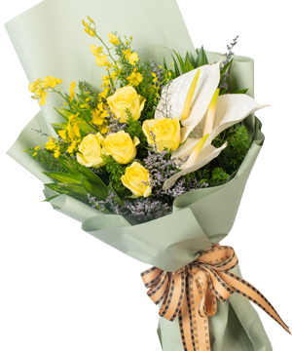

*"Fresh flowers are always considered a meaningful bridge for words of love. A solemn bouquet of flowers with the yellow color of pink moonlight symbolizes luck and fortune. Red carnation with a meaningful message about Deep gratitude and strong wolf snout flower reaching out to symbolize prosperity will be a perfectly suitable choice for conferences and events that need to honor and pay tribute to partners or delegates who have contributed the power to create overall success at work.*